

**USER GUIDE**

**HYPER TASK**

|  |  |  |
| --- | --- | --- |
| **Supervisor:** | *NGUYEN NGO PHUOC* | |
| **Semester:** | *3* | |
| **Batch No:** | *T1.1908.E0* | |
| **Group No:** | *02* | |
| **Order:** | **Full name** | **Roll No.** |
| *1.* | *Duong Ngoc Hai* | Student1198484 |
| *2.* | *Nguyen Hien Long* | Student1198731 |
| *3.* | *Nguyen Xuan Phong* | Student1198583 |
| *4.* | *Le Tuan Khang* | Student1204495 |

***Month****: 08* ***Year****: 2021*

# TABLE OF CONTENTS

TABLE OF FIGURE ii

I. USER PAGE 1

1. Header 1

2. Footer 2

3. Home page 3

4. Contact us page 4

5. Product Page 5

6. Product details page 6

7. Login Page 7

8. Register Page 9

9. Profile Page 10

10. Edit information page 11

11. Change Password 12

12. Change Avatar Page 13

13. Cart page 14

14. Checkout page 15

15. User order manager page 16

Admin pages Error! Bookmark not defined.

1. Dashboard 17

2. Product 18

3. Category 20

4. List User 21

5. Message 21

6. Feedback 22

7. Order 23

# TABLE OF FIGURE

Figure 1. Header before login 1

Figure 2. Header after login 1

Figure 3. Footer 2

Figure 4. Homepage #1 3

Figure 5. Homepage #2 3

Figure 6. Product page 5

Figure 7. Product detail page 6

Figure 8. Login Page 7

Figure 9. Register Page 9

Figure 10. Profile Page 10

Figure 11. Edit Profile Page 11

Figure 12. Change password page 12

Figure 13. Change avater page 13

Figure 14. Cart page 14

Figure 15. Checkout page 15

Figure 16. User order manager page 16

Figure 17. Admin DashBoard 17

Figure 18. Product managerment page 18

Figure 19. Add and edit image popup 19

Figure 20. Category managerment page - admin 20

Figure 21. Feedback list 22

Figure 22. Feedback details 22

Figure 23. Order list 23

# Login Page – Khang

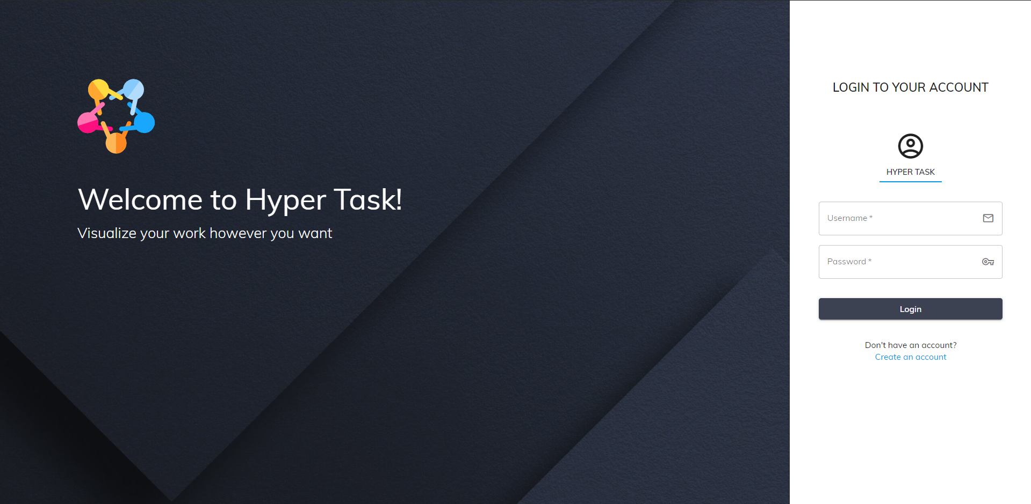

The login page is the first page a user lands on a website. In the Login page, users can access the page by filling in the fields “Email or username” and “Password” (In case they have an account). If “Email” and “Password” are correct, the system will notify successful login and return to the homepage. If the account is wrong, there will be a message and proceed to log in again. Even if the user closes the web, on the next visit, they don't need to log in again until they log out.

**Attention**: Users must follow these rules.

|  |  |
| --- | --- |
| **Field Name** | **Rules** |
| Email or username | Required and have to correct with email or username they have register |
| Password | Required |

* Login Page errors when not follow the rule

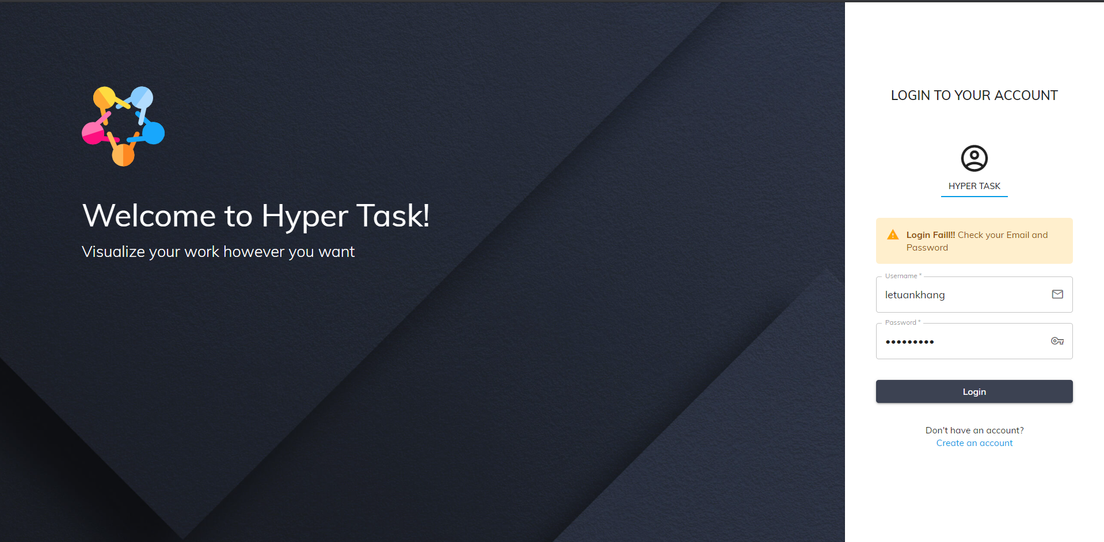

# Register Page – Khang

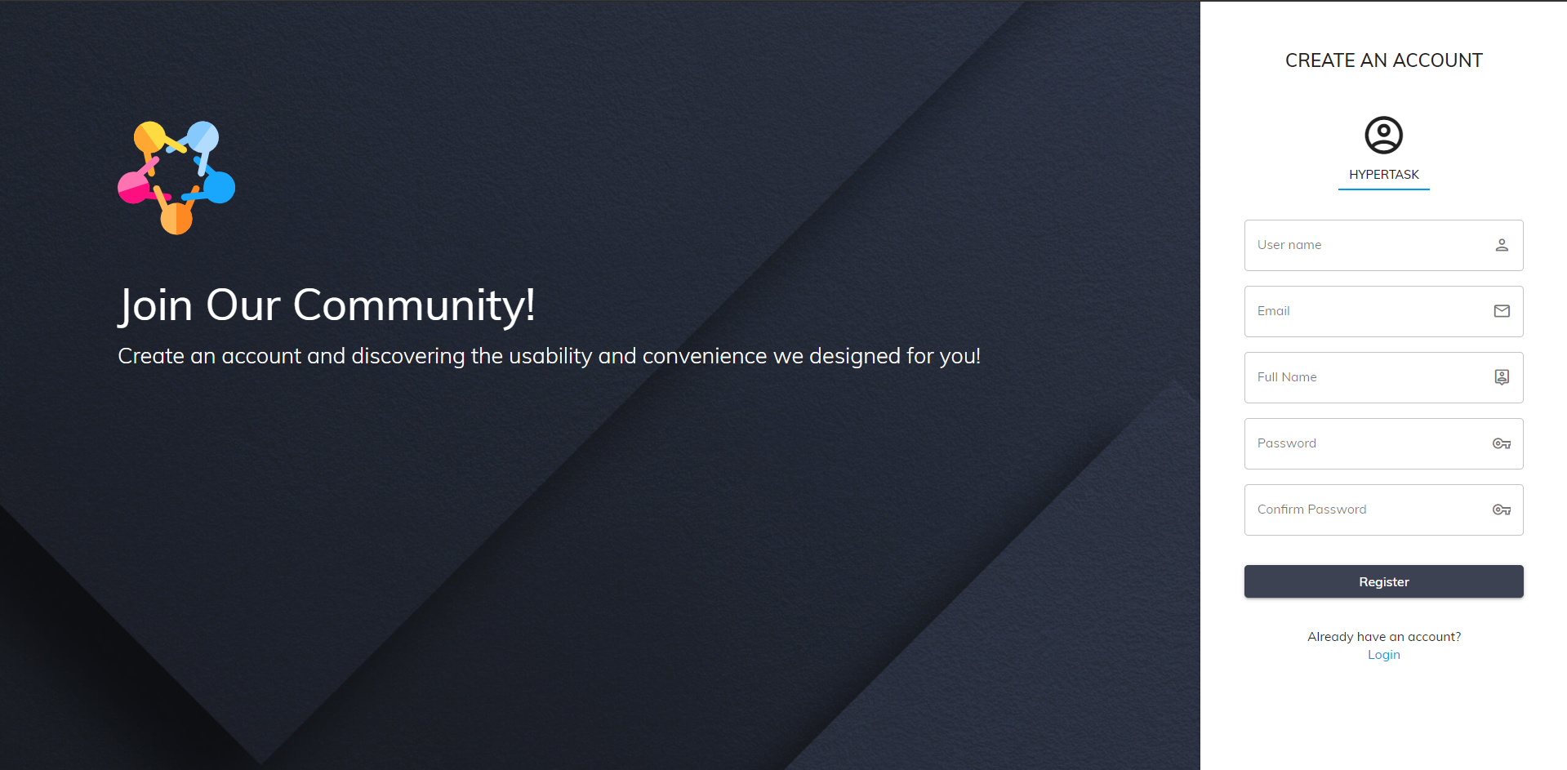

Registration page (Register), users can create new accounts to perform tasks on Hyper Task. Once the user fills in all the required fields correctly according to the website instructions, they can click Register to create their new account.

**Attention**: Users must follow the following rules:

|  |  |
| --- | --- |
| **Field Name** | **Rules** |
| Username | Minimum 5 characters with no special characters and not the same as registered usernames |
| Email | Minimum 5 characters with no special characters and not the same as registered email |
| FullName | Does not contain special characters that may contain Vietnamese letters |
| Password | Minimum 6 characters |
| Password confirm | Minimum 6 characters and must be the same as the password |

* **Register page errors when not follow the rule**

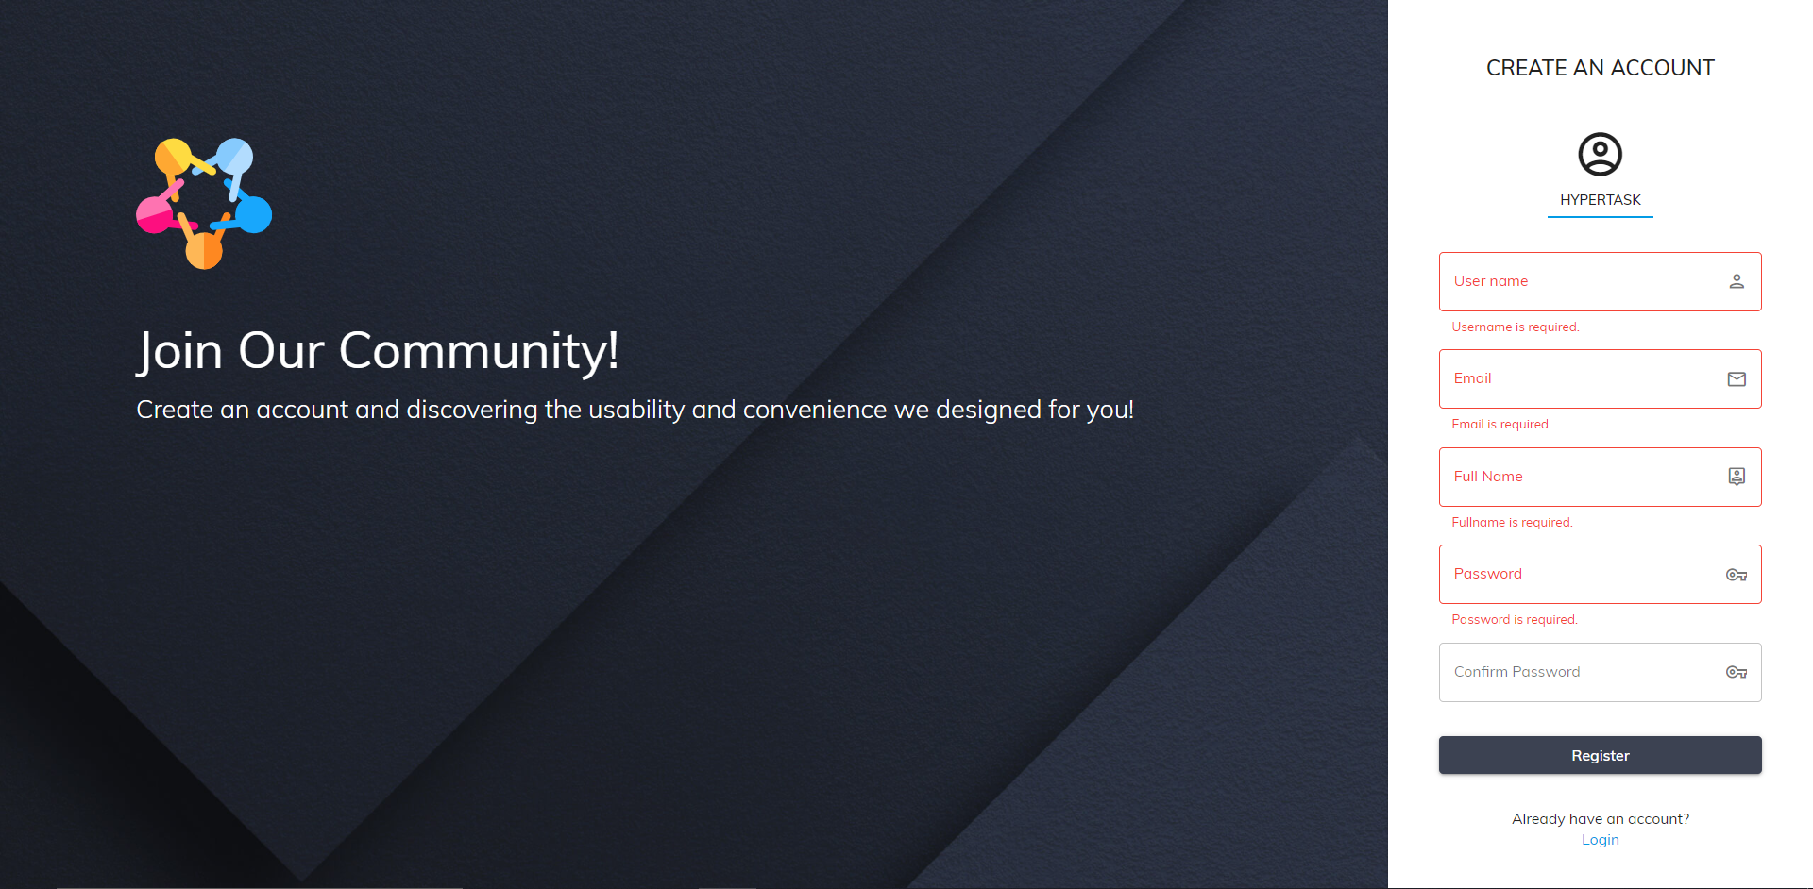

# Header – Hải

# Dashboard page – Hải

# Features page – Hải

# Contact us – Hải

# Profile page – Phong

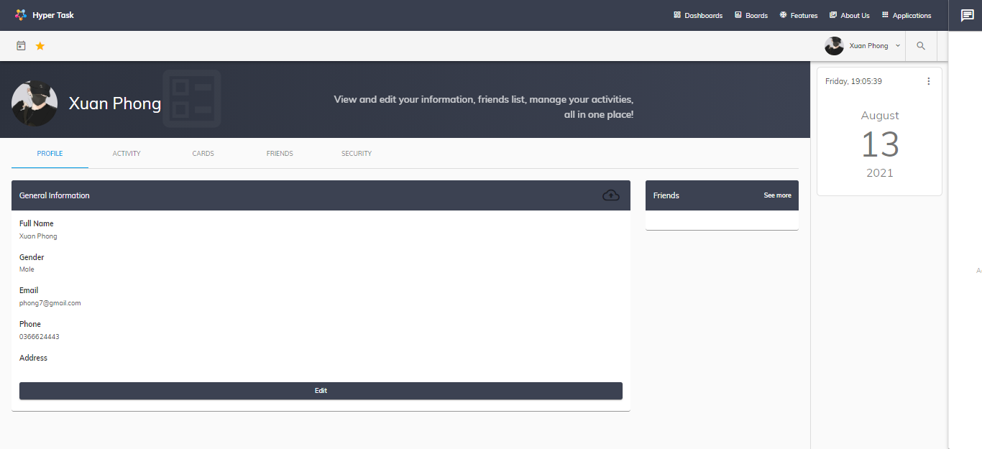

Display user information , to get into this page user have to create account and login.

This page to Edit User’s Full Name,Email, Address,, PhoneNumber,Gender

Attention: User have to follow these rules:

|  |  |
| --- | --- |
| **Field Name** | **Rules** |
| Email | Minimum 5 characters with no special characters and not the same as registered email |
| FullName | Does not contain special characters that may contain Vietnamese letters |

# + Change Avatar: Click Icon upload in Profile page.User can upload avatar this here

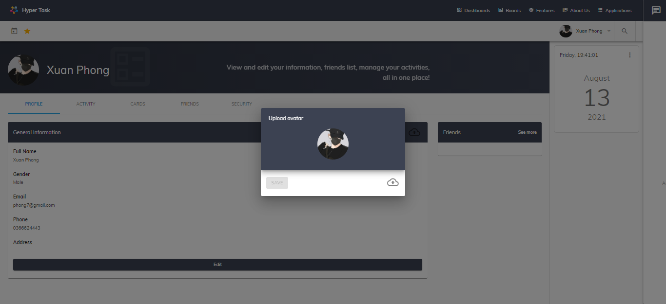

# User’s activity page – Phong

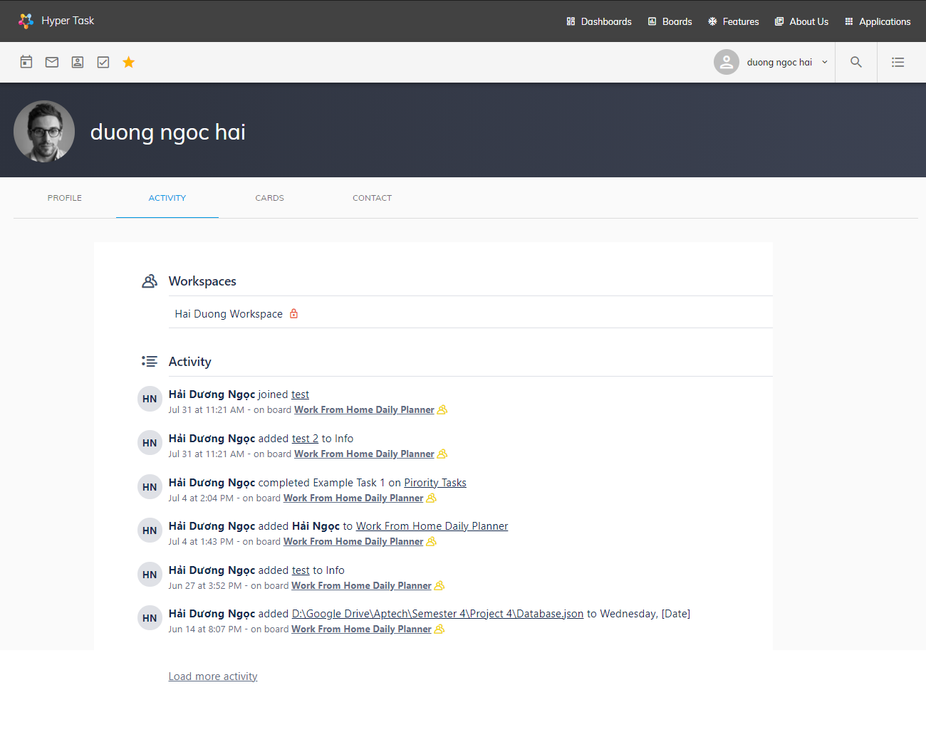

This page displays a history of user activities on their boards, include many activities such as joining boards, adding, editing, deleting board data, ….

# User’s card page – PhongDisplay a list of user’s card, these cards may be created by them or assigned to them, so they can track the status of them., quickly view ,double click on the card to move to the corresponding board.

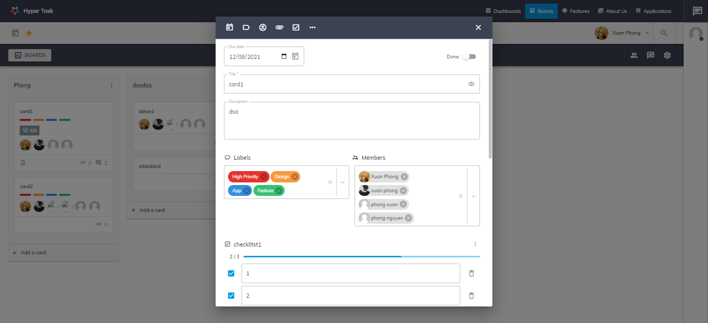

# Friends page – Khang

* **Add Friend Tab**

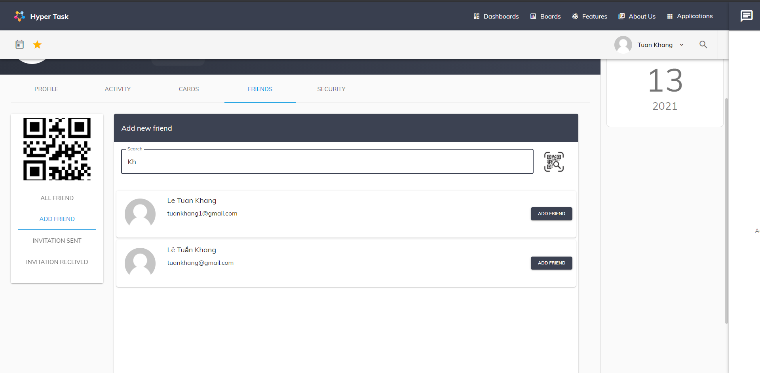

Add Friend Tab: Users can search for friends in this page by entering username or email in the search box and then clicking the Add Friend button will have a message that the request has been successfully sent.

Or users can search by QR code by clicking on the QR code icon

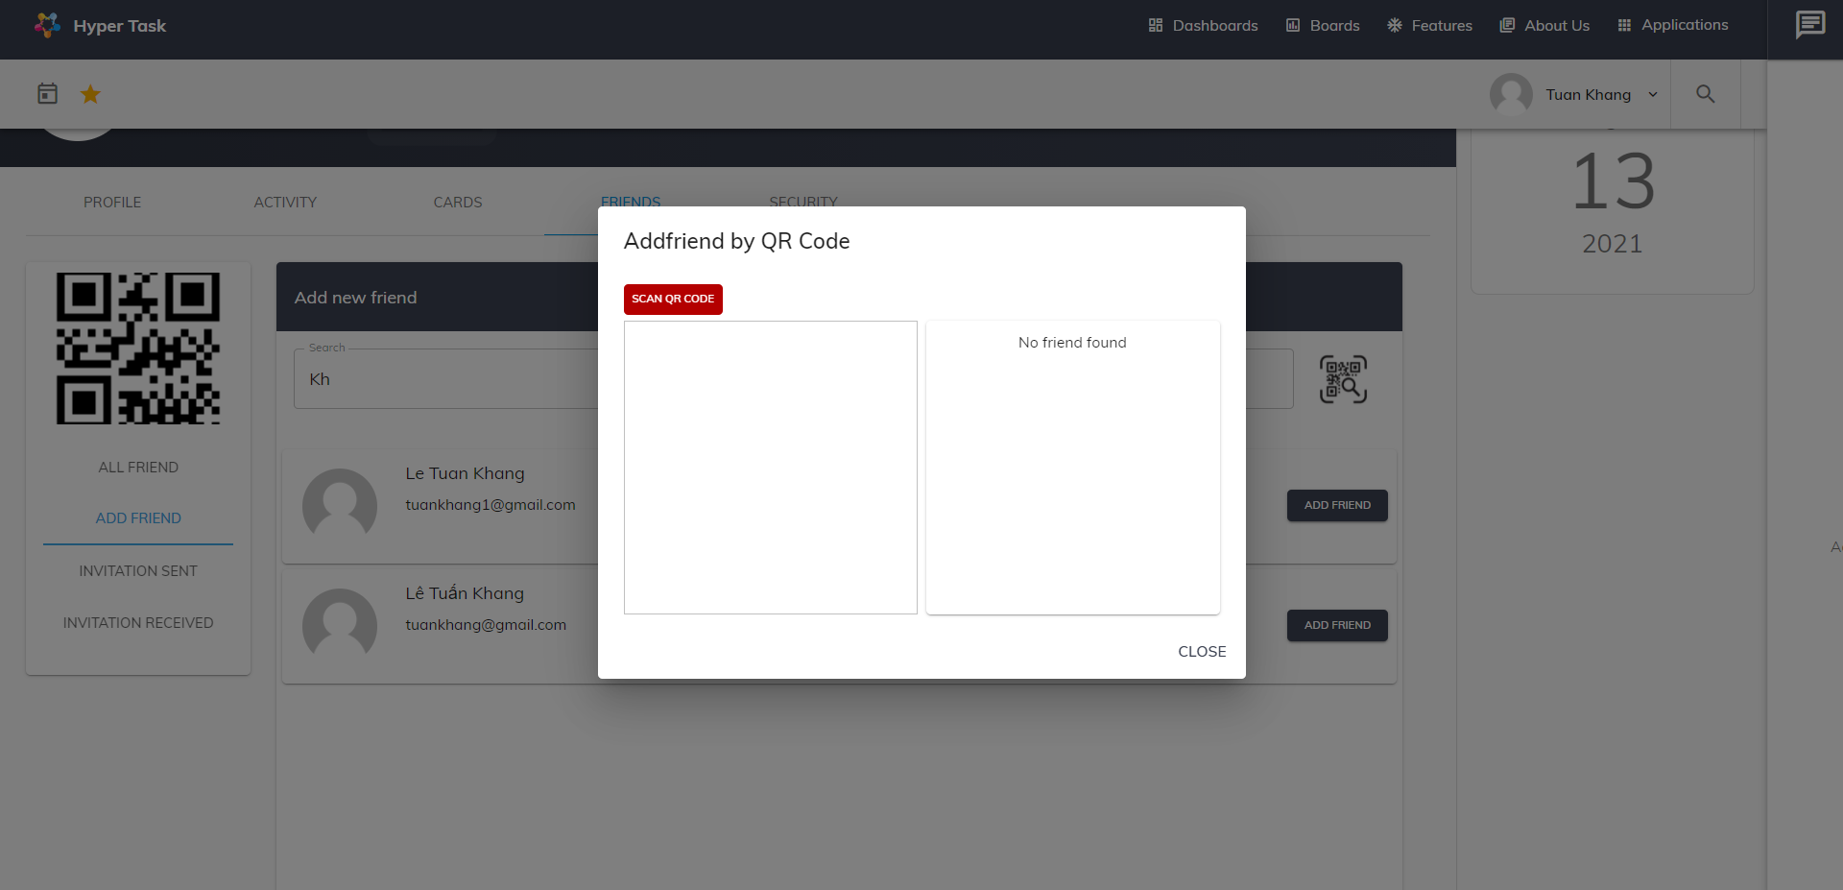

Click Scan QR Code button and choose QR code image

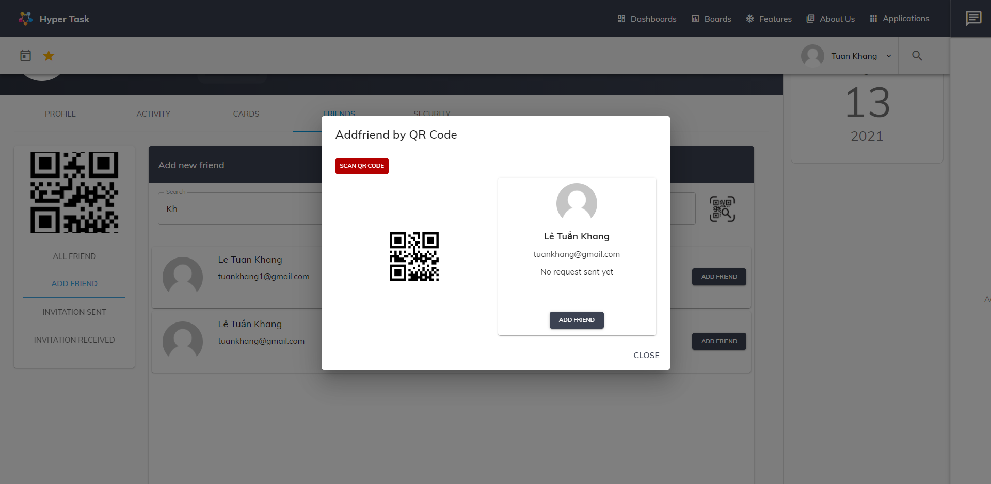

Information about the person you are looking for will be displayed

* **Invitation Sent Tab**

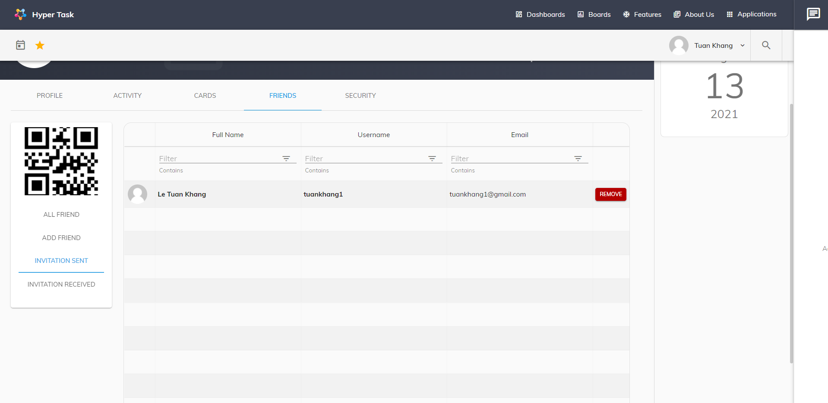

Here displays a list of friend requests sent by the user. User can cancel the friend request by clicking on the button to remove the sent invitation

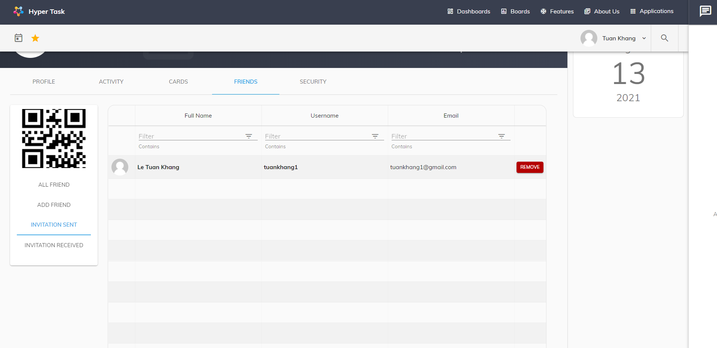

You can choose to remove or cancel

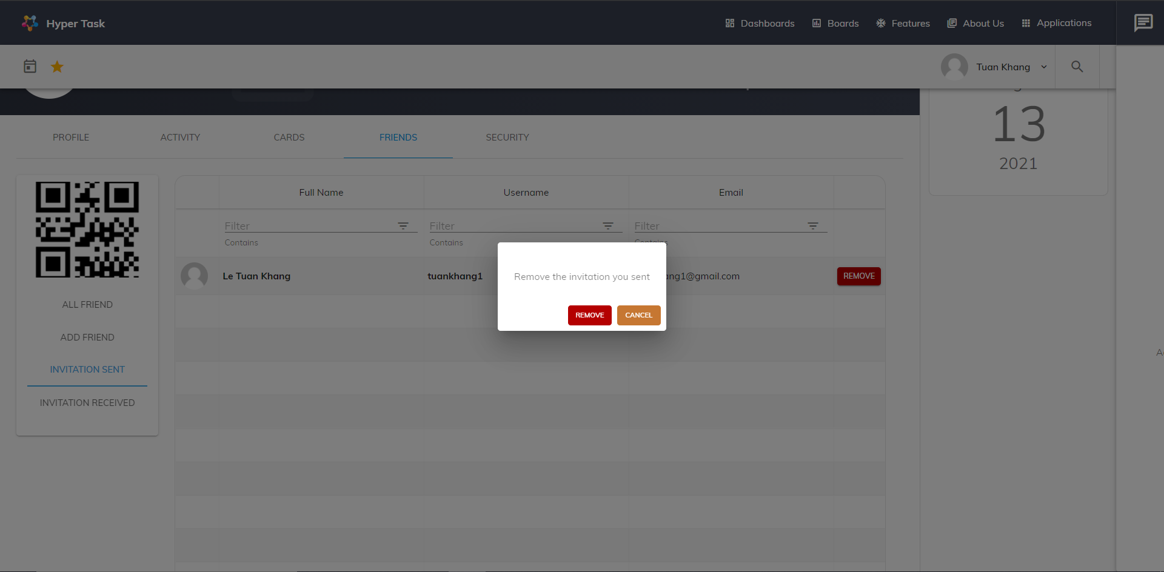

* **Invitation Receive Tab**

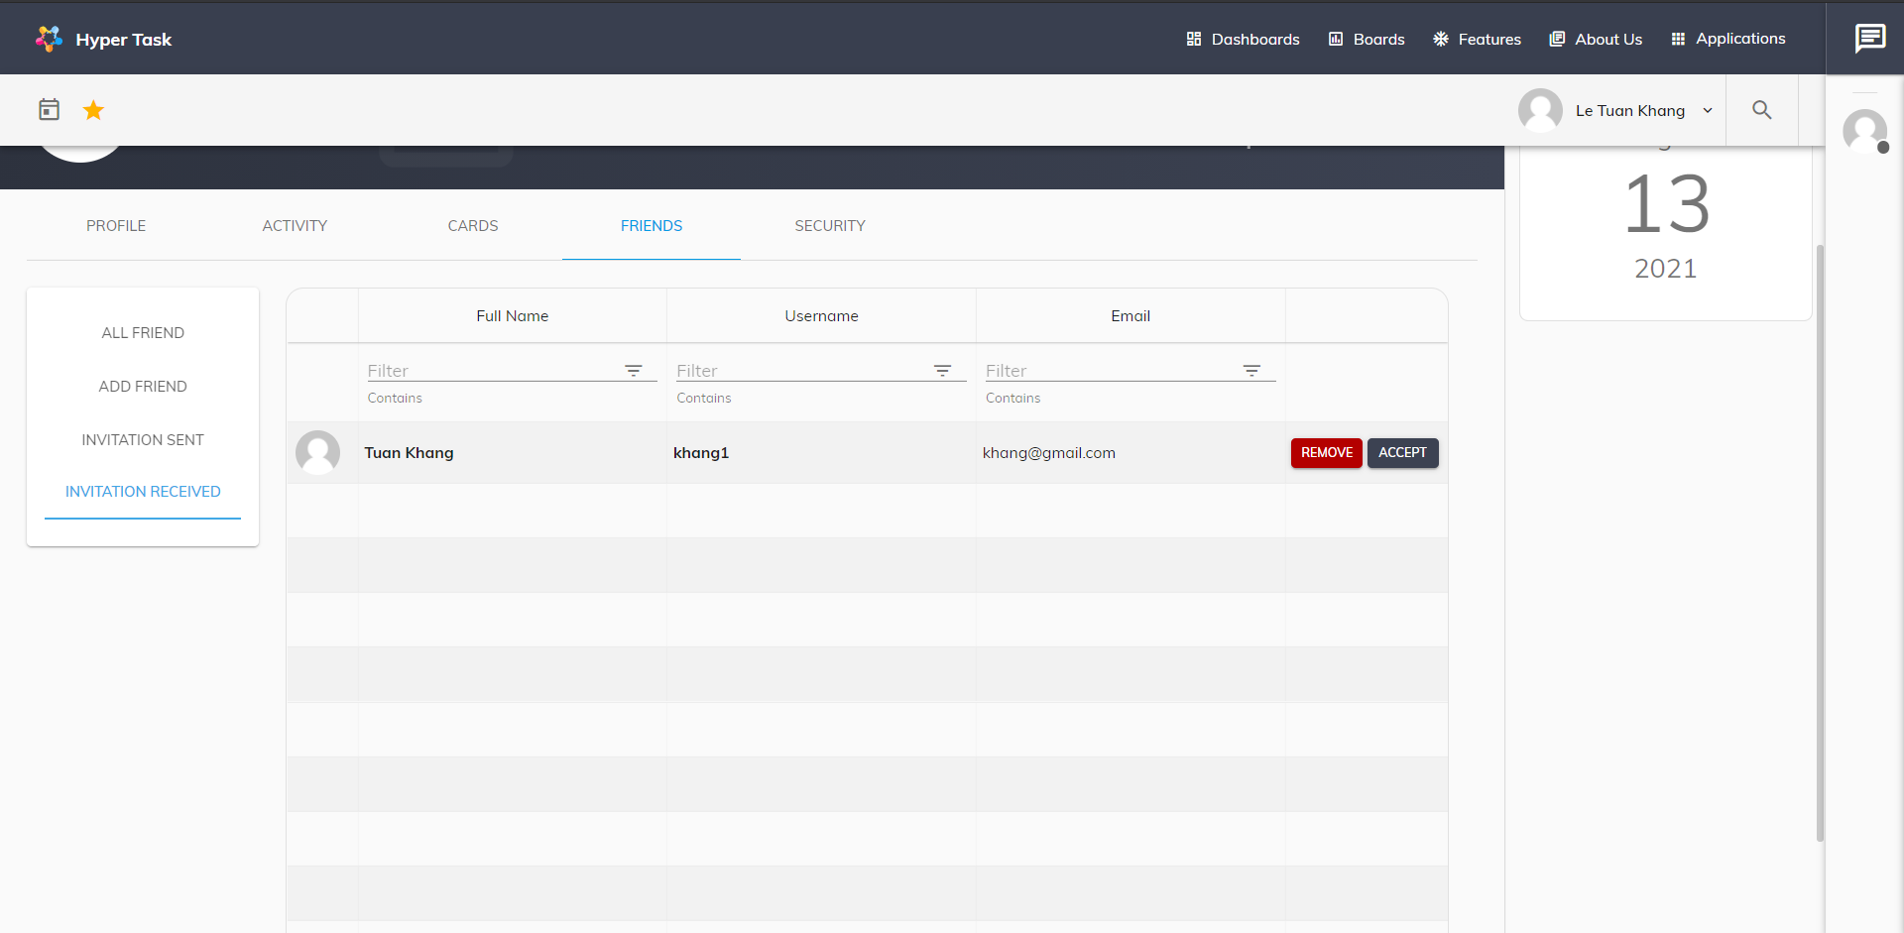

Here you can accept or remove invitations received from others

* **Friend Tab**

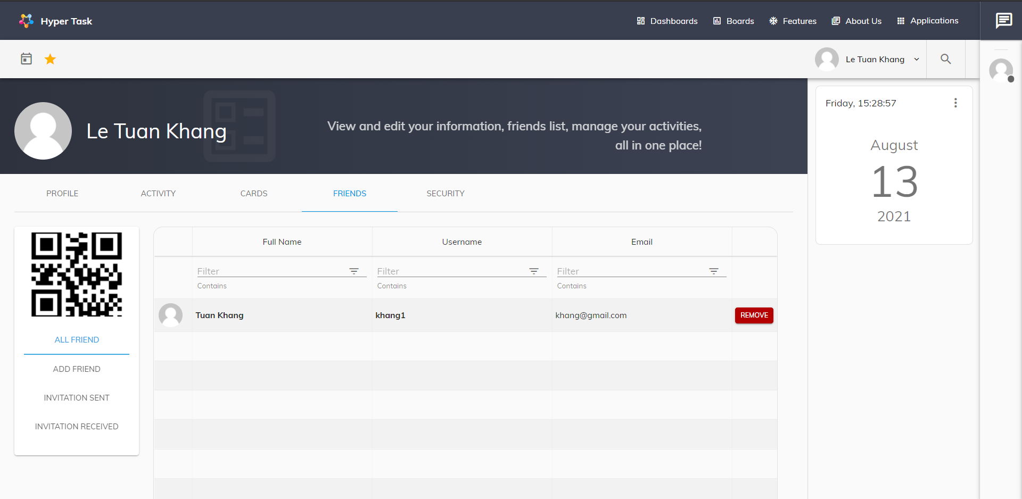

Friend tab shows all of the user's friends, Users can delete friends in this tab

# Change password page – Phong

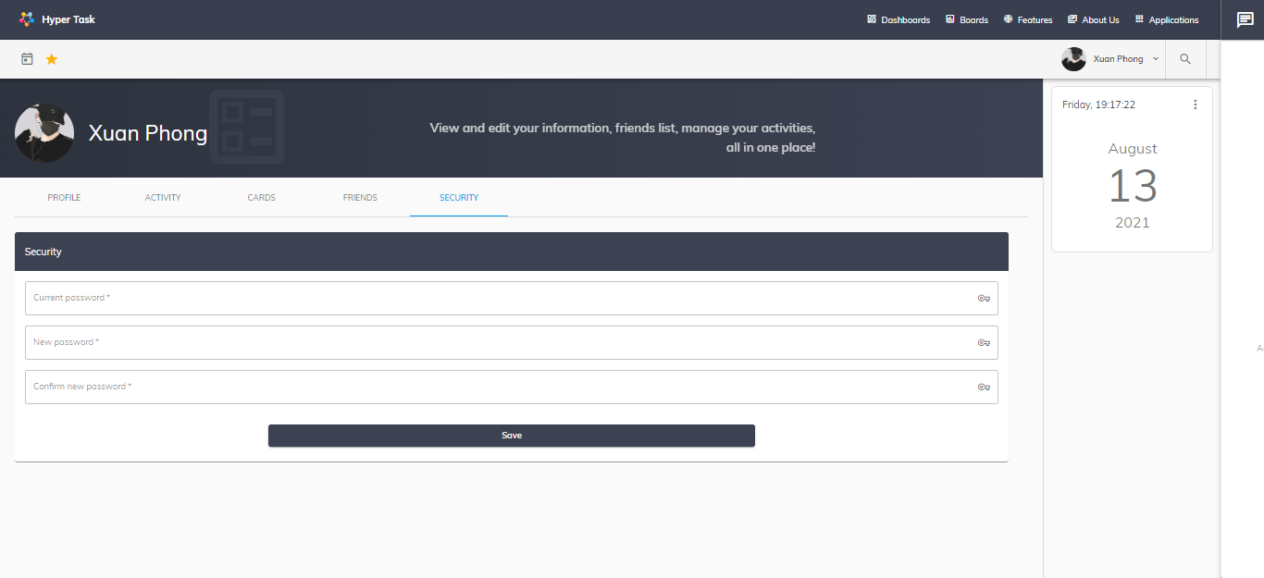

Change Password Page: Access by tab Security. User can change their password here.

Attention: User have to follow these rules:

|  |  |
| --- | --- |
| **Field Name** | **Rules** |
| Old Password | Required & Have to correct with their curent password |
| New Password | Required & At least 6 values |
| Confirm New Password | Required & correct with New Password |

# Boards page - Long

# Board details page - Long

# Chat component – Hải

# Note page – Phong

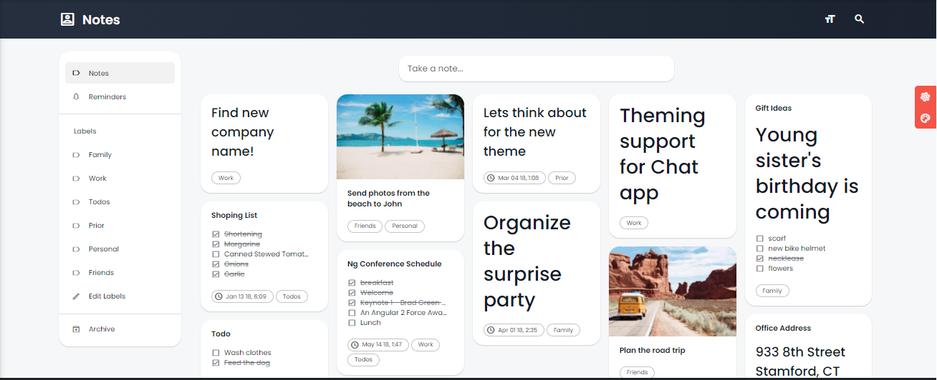

Note Page: User can editing as you write notes,lists,and to-do lists

- Create note: Click “Take a note” in note page default. Fill in the information and click create

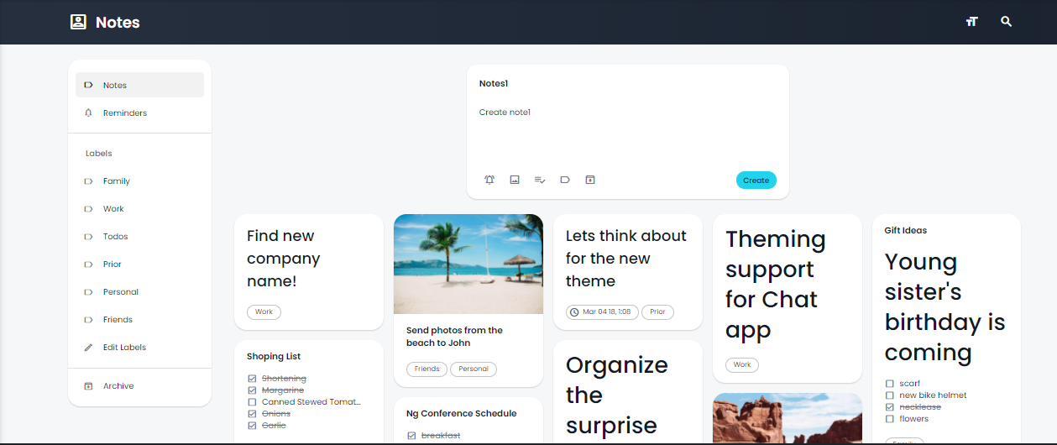

- Edit note: click card note. Fill in the information and note will be update real time

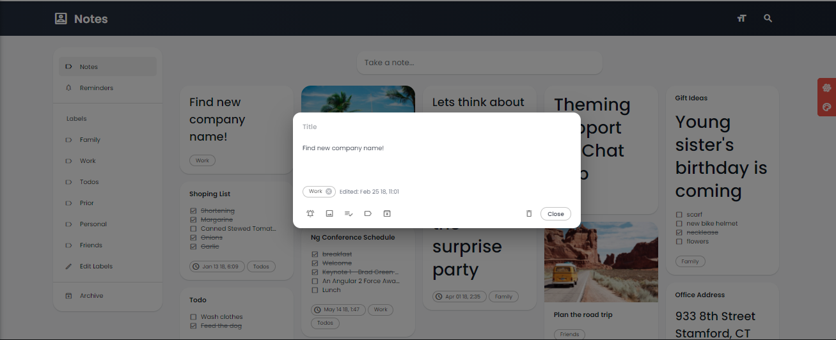

-Create, edit, remove Labels: Click “Edit Labels” and Create, edit, remove Labels here

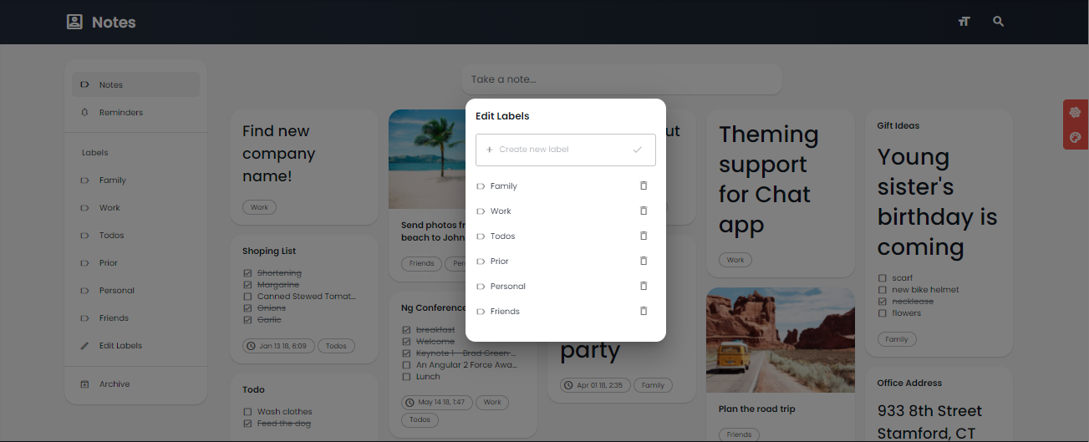

**16.Calendar page**

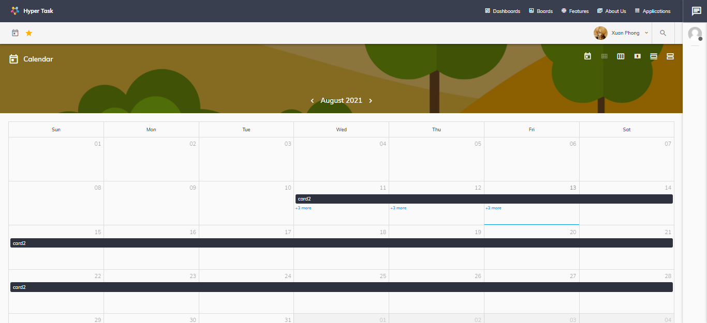

Calendar page: User can view calendar by month week or day and view due date their card.

Clicking on the card will show a popup showing detail due date card

